**WEEK 2**

**1.Write a C/Java program to accept a number n from the user and print n rows of output**

**as given below if n=4.**

1

2 3

4 5 6

7 8 9 10

import java.util.Scanner;

class pattern{

public static void main(String argrs[]){

int n,count=1;

Scanner in=new Scanner(System.in);

System.out.println("enter a number");

n=in.nextInt();

for(int i=1;i<=n;i++)

{

for(int j=0;j<i;j++)

{

System.out.print(count+" ");

count++;

}

System.out.print("\n");

}

}

}

Output:

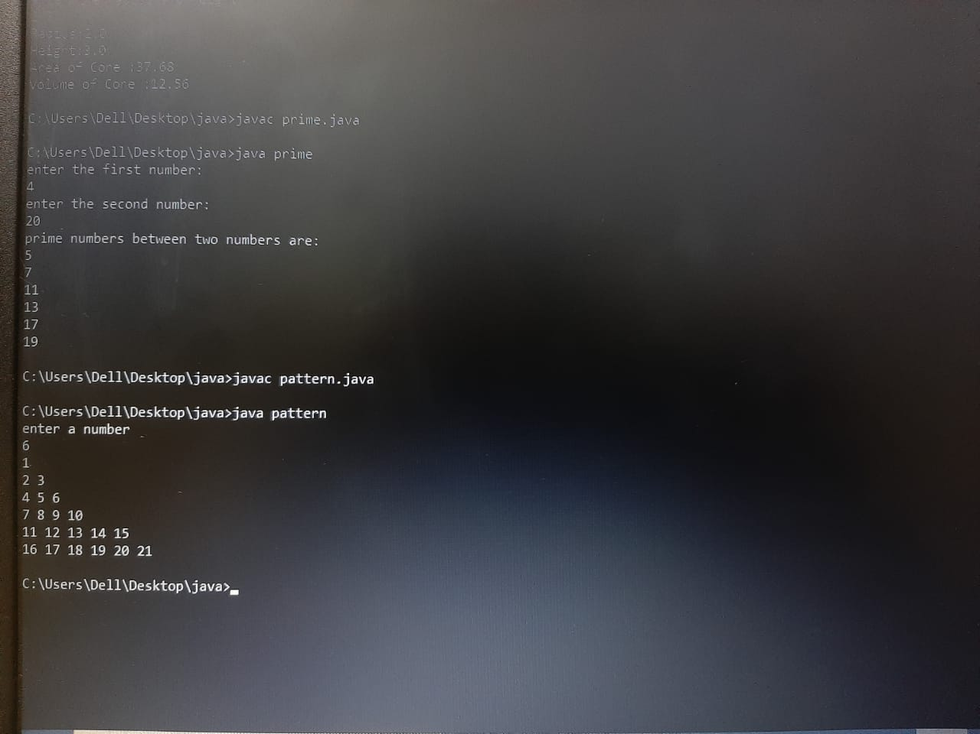

**2.Wriite a C/Java program to accept the CIE marks (Out of 50) and SEE marks (Out of**

**100) of a student and print his/her grade. Use if… elseif ladder**

import java.util.Scanner;

class student{

public static void main(String args[]){

int see,cie,marks;

char grade='Z';

Scanner in=new Scanner(System.in);

System.out.print("enter the cie marks(out of 50)\n");

cie=in.nextInt();

System.out.print("enter the see marks(out of 100)\n");

see=in.nextInt();

see=see/2;

marks=cie+see;

if (marks>100){

System.out.println("invalid marks");

}

else if (marks>=90)

grade='A';

else if(marks>=80&&marks<90)

grade='B';

else if (marks>=70&&marks<80)

grade='C';

else if (marks>=60&&marks<70)

grade='D';

else if (marks>=50&&marks<60)

grade='E';

else

grade='F';

System.out.println("grade is:" + grade);

}

}

OUTPUT:

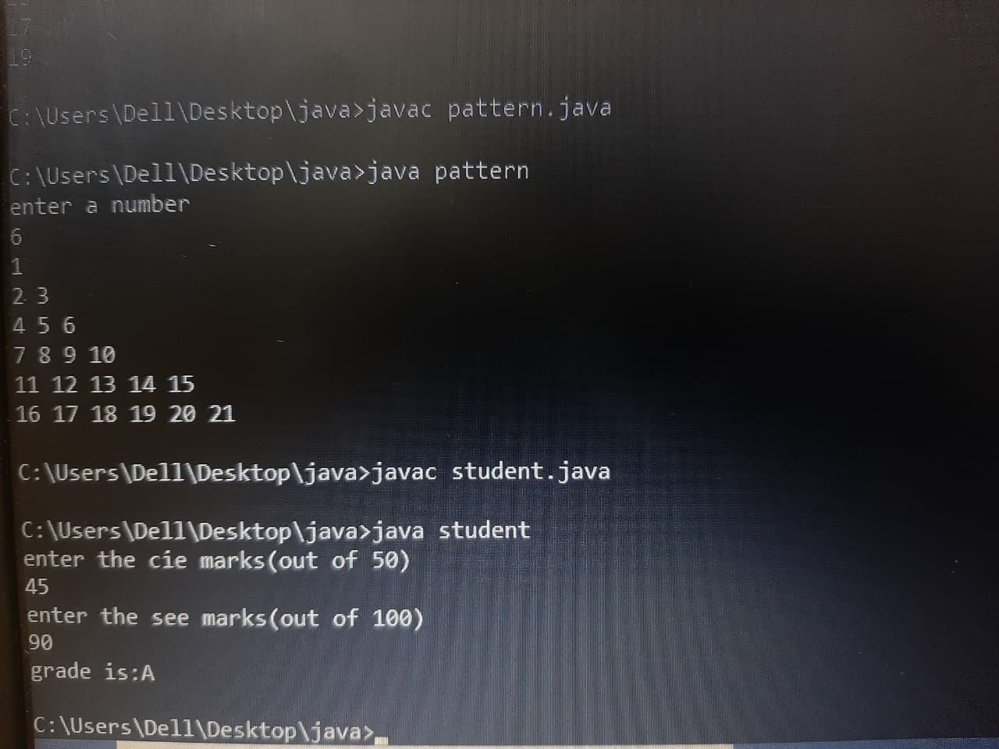

**3.Write a C/Java program to print the prime numbers between given two integers**

**(inclusive). Accept these two integers from the user.**

import java.util.Scanner;

class prime{

public static void main(String args[]){

int m,n,flag;

Scanner in=new Scanner (System.in);

System.out.print("enter the first number: \n");

m=in.nextInt();

System.out.print("enter the second number:\n");

n=in.nextInt();

System.out.print("prime numbers between two numbers are:\n");

if(m==0||m==1)

{

System.out.print("1 \n");

m=2;

}

for(int i=m;i<=n;i++){

flag=0;

for(int j=2;j<=i/2;j++)

{

if(i%j==0)

{

flag=1;

break;

}

}

if(flag==0)

{

System.out.println(i);

}

}

}

}

OUTPUT:

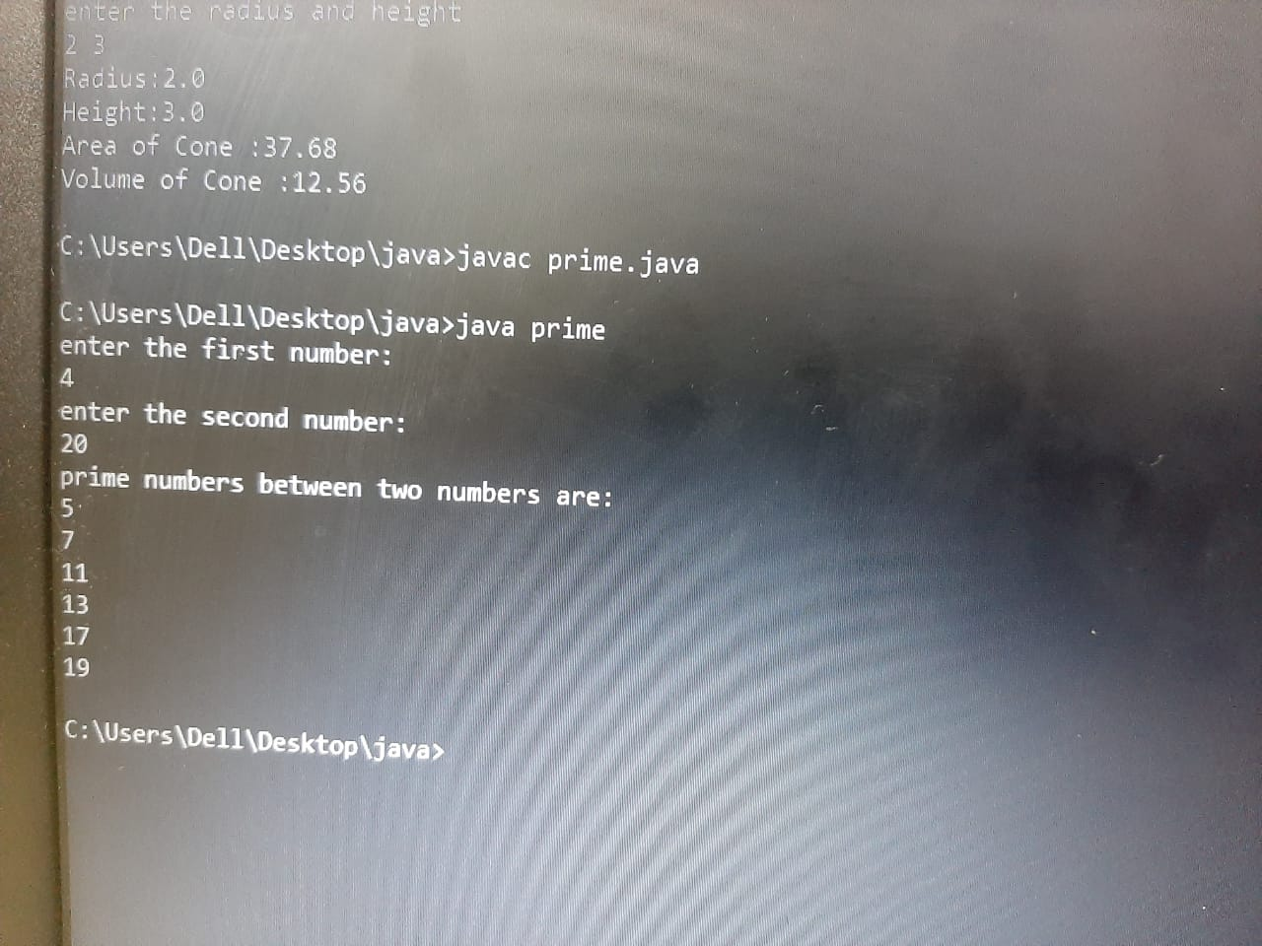

**4.Write a C/Java program which prints the area and volume of any one of the given**

**shapes given below. Accept the choice of the shape, appropriate inputs from the user,**

**calculate and display the area and the volume of the same. Repeat this with different**

**shapes till the user wishes to stop.**

**-Cylinder: Area : A=2πrh+2πr 2 Volume: V=πr 2 h**

**-Cone: Area: A=πr(r+ √(h 2 +r 2 )) Volume: V= πr 2 h/3**

**-Sphere: Area: A= 4πr 2 Volume: V= (4/3) πr**

import java.util.Scanner;

class AreaVol{

public static void main(String args[]){

int choice;

double r,h,a,v;

Scanner in=new Scanner(System.in);

System.out.println("The choice of shapes are 1)cylinder 2)cone 3)sphere 4)exit");

System.out.println("Enter the choice:");

choice=in.nextInt();

System.out.println("enter the radius and height");

r=in.nextInt();

h=in.nextInt();

if(choice==1)

{

System.out.println("Radius:" +r);

System.out.println("Height:" +h);

a=2*3.14*r*h+2*3.14*r*r;

v=3.14*r*r+h;

System.out.println("Area of Cylinder :" + a);

System.out.println("Volume of Cylinder :" + v);

}

else if(choice==2)

{

System.out.println("Radius:" +r);

System.out.println("Height:" +h);

a=3.14*r*r+3.14*r*Math.sqrt(h*h+r*r);

v=3.14*r*r*h/3;

System.out.println("Area of Cone :"+a);

System.out.println("Volume of Cone :" +v);

}

else if(choice==3)

{

System.out.println("Radius:" +r);

System.out.println("Height:" +h);

a=4*3.14*r*r;

v=4/3*3.14*r*r*r;

System.out.println("Area of Sphere :" +a);

System.out.println("Volume of Sphere :" +v);

}

else if(choice==4)

System.out.println("invalid input");

}

}

OUTPUT:

